**Date: _**

**Project Work: Review-2 Report**

**I. Project Title: AI Based Exam Proctoring System**

**II. Datasets / Project Flow/Modules description**

**Project Flow:**

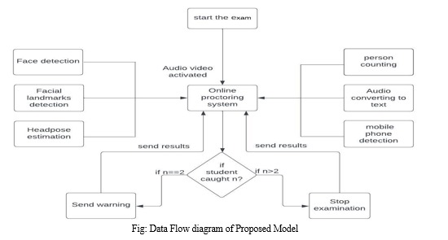

**Fig 1. Data Flow diagram of Proposed Model**

In this project, using a webcam, we can record video input which is used to determine a number of factors such as candidate face detection and facial landmarks, head posture estimation, detection malicious objects. These factors are used to detect harmful behaviour by candidates.

The system consists of basic components that continuously estimate student behaviour. In this project, we have several modules: face and facial landmarks detection, malicious object detection, audio recognition, head pose estimation, lip movement detection and gaze detection.

**Modules description**

1. **Face and Facial landmark Detection:** In this case we first detect the face as input image and then the facial landmarks are extracted. This is a task that considers facial landmarks and observes them throughout the test to determine if there is cheating. We have also included face spoofing to ensure that only the specific person registered to take the exam takes the exam.
2. **Malicious Object Detection:** Cell phones, books, chairs, few people, etc., all point to malicious objects. Detecting the above items in a candidate's test environment may also provide us with information about cheating techniques.
3. **Audio Recognition:** In this, we will record the audio through the microphone, convert it to a text file and send it to a supervisor to identify any form of fraud during examination. We have also identified the background noises that can lead to any kind of disqualification from the online examination. We also record the noises via the microphone and convert this recording into the appropriate string and a text file which is later transferred to the proctor to check for possible cheating during the exam. If the noise is consistent, we can conclude that the expected noise was recorded correctly. If the noise does not match, we can conclude that the expected sound is not recorded correctly.
4. **Head pose Estimation:** A candidate's head movement can be an indication that they have engaged in fraudulent activities. We can check if the student is distracted from the exam. Here we estimate the head position if he turns left or right and up or down and know if he is cheating or not.
5. **Lip movement Detection:** Simple way to detect open mouth is using features from face recognition.The strategy we used in this detection is real-time webcam video. We will also get the details of the facial features in the standard output, including the upper and lower lip.
6. **Gaze Detection:** We can use eye tracking to identify deviant behaviour in an online exam. We create the gaze dataset while students are taking an online test. Basic research on different eye sight patterns in online exams and outlines fraud detection mechanism.

**III. Project Design(UML Diagrams)/ Methodology/Framework/Architecture/Proposed**

**Algorithm**

**SYSTEM DESIGN**

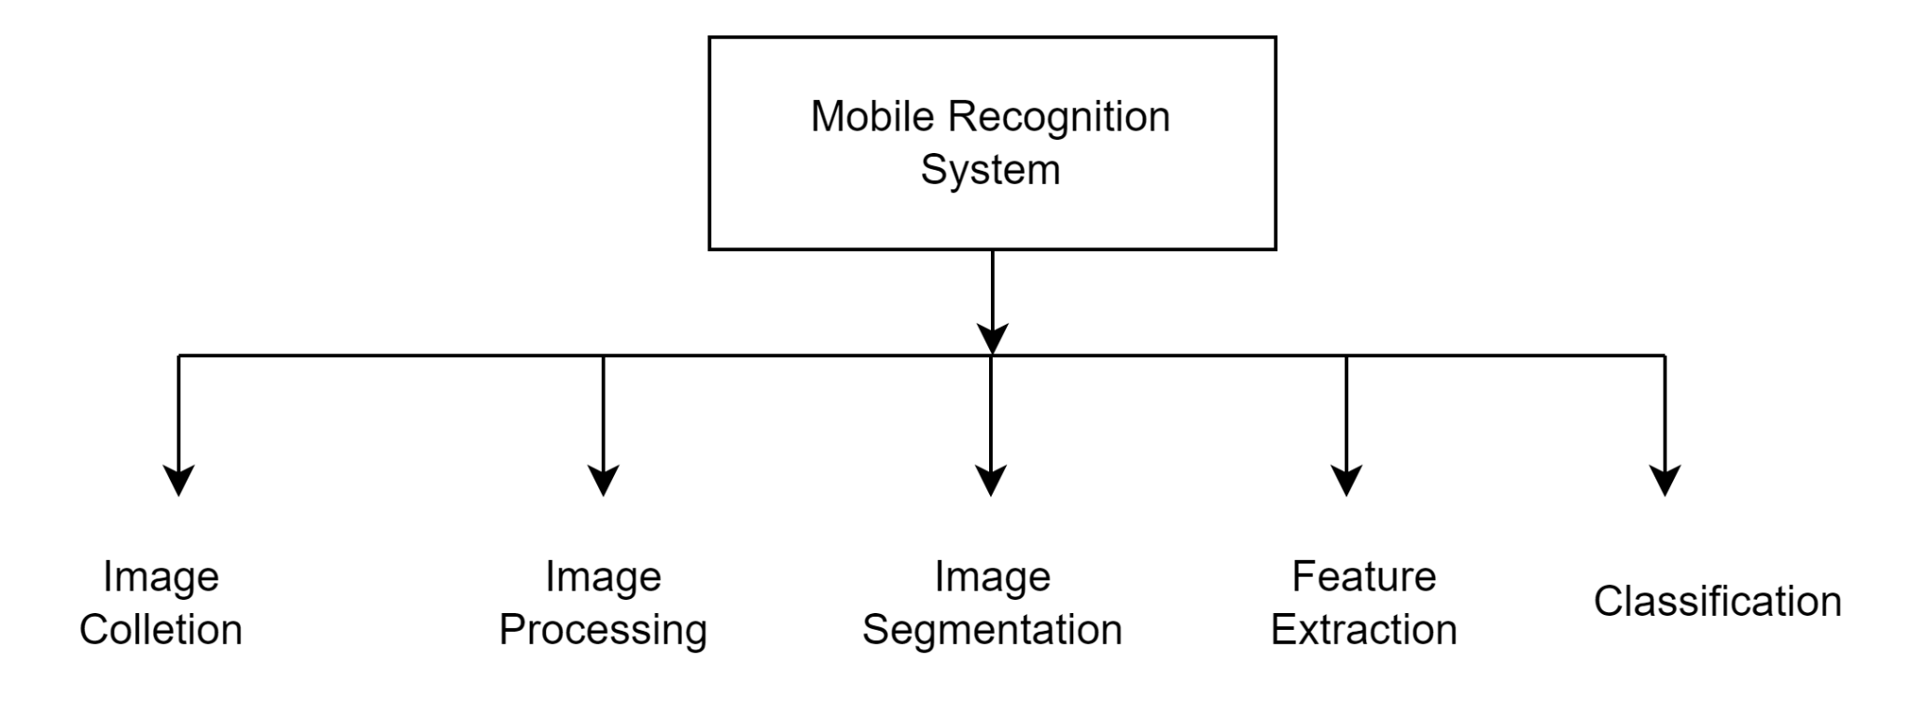

**Fig 2 . System Design**

The design which is used to design the software related requirements. In this paper, complete system design is generated and shows how the modules, sub modules and the flow of the data between them are done and integrated. It is very simple phase that shows the implementation process. The errors done here will be modified in the coming processes. The system design mainly consists of:

1. Image Collection

2. Image Preprocessing

3. Image Segmentation

4. Feature Extraction

5. Training

6. Classification

**1. Image Collection:** Input to proposed system is the real time video. The real time video is captured from the web cam of the user’s pc or laptop.

**2. Image Pre-processing:** Goal of pre-processing is an improvement of image data that reduces unwanted distortions and enhances some image features important for further image processing.

Image pre-processing involves three main things. a) Gray scale conversion b) Noise removal c) Image enhancement

**3. Image Segmentation:** The next step after image pre-processing was to segment theobject from the surrounding image. Since a clear color distinction existed between the object and the face, thresholding was very suitable for the task. A black and white image was produced with its contrast adjusted to provide better segmentation.

**4. Feature Extraction:** The purpose of feature extraction is to suppressed the original image data set by measuring certain values or features that helps to classify different images from one another.

**5. Classification:** A Convolutional Neural Network (ConvNet/CNN) is a Deep Learning algorithm which can take in an input image, assign importance (learnable weights and biases) to various aspects/objects in the image and be able to differentiate one from the other.

The First step is to registration of students using their personal details and face image on the platform. For every test a student get register with the latest face image which will be verified with an image stored in database. Objects detection, Mouth open detection, Eye tracking, Multiple Face detection and no face detection will get detected. Head Posing will be tracked, Multiple Voices will be detected. If a student is found doing fraudulent activities in logs it will leads to disqualification.

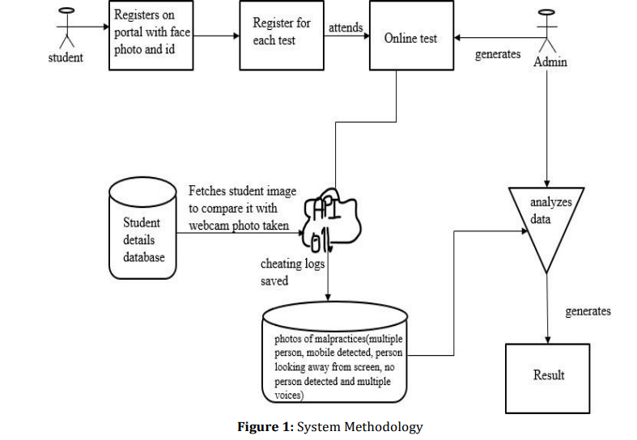

**Fig 3. System Methodology**

**SYSTEM REQUIREMENTS**

The hardware and software requirements are very minimal and the software can run on most of the machine even of the past. Here we have used the system of below specification to develop. To be used efficiently, all computer software needs certain hardware components or other software resources

to be present on a computer. These prerequisites are known as (computer) system requirements and are often used as a guideline as opposed to an absolute rule. Most software defines two sets of system requirements: minimum and recommended. With increasing demand for higher processing power and resources in newer versions of software, system requirements tend to increase over time.

**Hardware Requirements**

Processor type : intel i3/i5

Processor speed : Minimum 2.4 GHz or fasterRAM : 4/8 GB

HARD DISK : 500 GB

**Software Requirements**

Operating System : Windows XP / 10

Coding Language : Python 3 Tool : Python IDLE

**ALGORITHMS**

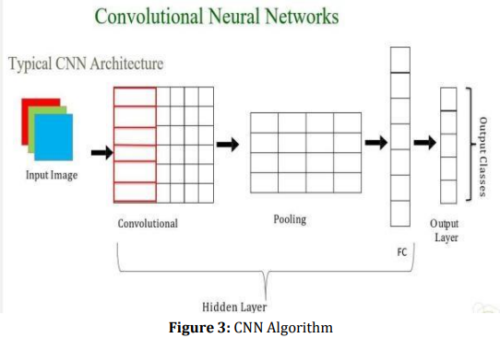

**Fig 4. CNN Algorithm**

Convolutional neural network (CNN) is a type of artificial neural network used in image recognition and processing that is specifically designed to process pixel data. Convolutional neural network is the special type of feed forward artificial neural network in which connectivity between the layers are inspired by visual cortex. CNN is a class of deep neural network which is applied for analyzing visual imagery. In neural networks, Convolutional neural network (ConvNets or CNNs) is one of the main categories to do images recognition, images classifications. Objects detections, recognition faces etc., are some of the areas where CNNs are widely used. Convolution is the first layer to extract features from an input image. Convolution preserves the relationship between pixels by learning image features using small squares of input data.It is a mathematical operation that takes two inputs such as image matrix and a filter.

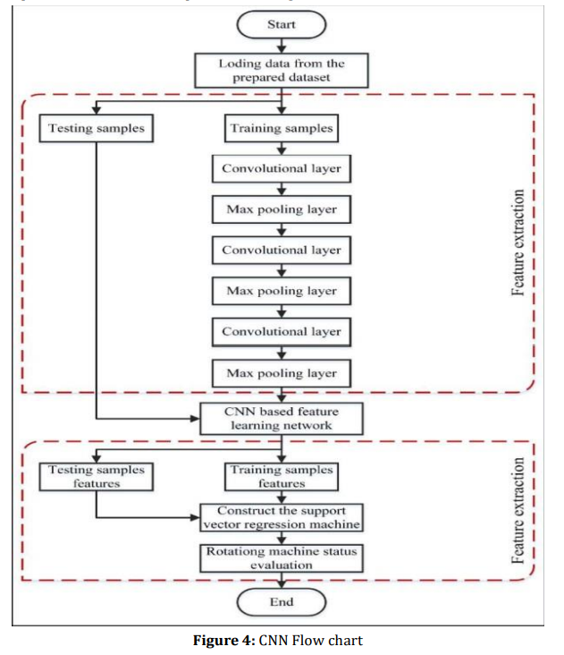

**Fig 5. CNN Flow Chart**

The input to the fully connected layer is the output from the final pooling or convolutional layer, which is flattened and then fed into the fully connected layer. it reduces the number of parameters to learn and the amount of computation performed in the network. The pooling layer summarizes the features present in the region of the feature map generated by a convolutional layer.

**Validation Process:**

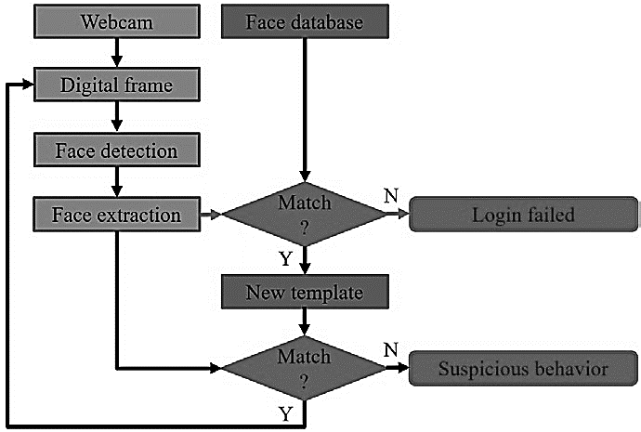

**Fig 6. Validation Process**

A VL with a gear train experiment used in an undergraduate mechanical engineering course was selected as the pilot prototype for validating the virtual proctor. Before demonstrating the validity of the implementation, suspicious behaviors were defined first. In order to explain this, a coordinate system was defined as shown in Fig 6. The behavior of “rotating head corresponds to a rotation about either the X axis or the Y axis. The behavior of “moving relative to webcam” corresponds to a translation along the X, Y and Z directions.

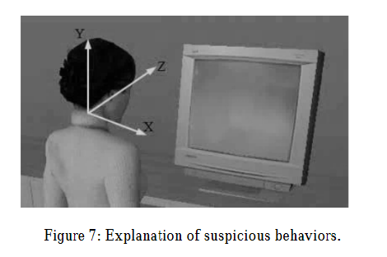

**Fig 7. Explanation of suspicious behaviour**

First, a student logs into the VL system with his/her name. Then, the webcam scans the student’s face for authentication purposes. If the authentication failed, this student is forced to exit the VL system. If the authentication was successful, the scanned frame is stored as the new template in the subsequent tracking and proctoring stage. Finally, the experiment is conducted under the supervision of the virtual proctor.

| **Submitted by:** | | | | |
| --- | --- | --- | --- | --- |
| **S.No** | **Roll No** | **Name of the Student** | **Signature of the student** | |
| 1 | 209X1A05H6 | P. Gokula Kishore Reddy |  | |
| 2 | 209X1A05H9 | V. Pranay Kumar Reddy |  | |
| 3 | 219X5A05L9 | M. Obula Sai |  | |
| **Project Guide Name & Designation**  Smt.B.Swathi,  Assistant Professor,  CSE Dept. | | | |
|  | | | |
| ___________________________ | | | |
| Signature with date | | | |